1. Consider a cup of coffee at 95oC and a bath of water at 40oC.  
   1. By considering the molecules of water, explain why the coffee is at a higher temperature?

**The coffee is at a higher temperature since the molecules of water have a higher average kinetic energy.**

* 1. Which has the greater internal energy, the coffee or the bath of water? Explain.

**The bath of water has the greatest internal energy, since internal energy is the sum total of the potential and kinetic energies of all the molecules of a substance, and there are many more molecules in the bath.**

1. The diagram below shows a reverse cycle air conditioner.

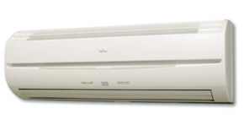

* 1. What does the term “reverse cycle” mean

**Reverse cycle means it can either heat or cool a room.**

1. Explain how the air conditioner is able to cool a room?

**A refrigerative air-conditioner acts as a heat pump. Inside a heat pump, a volatile liquid, known as a refrigerant, is used to remove heat. The refrigerant is circulated inside a closed circuit of pipes by a pump. Evaporation occurs inside the evaporator pipes as pressure is reduced through an expansion valve. The latent heat of vaporisation, required to evaporate to the liquid, is removed from the air, making it cooler. As the refrigerant condenses back to a liquid state outside the house, energy is released.**

1. Consider the following advertisement for an evaporative air cooler. Sketch a diagram of the internal structure of such a cooler and explain how it works from a particle point of view.

**5.** Complete the following conversions:

**As air is passes through the moist pads it causes evaporation to increase on the water.  
As the water evaporates, the most energetic molecules leave the water droplets and therefore the temperature of the water droplets decreases.  
The warm air passing by the now cooler droplets loses heat to the water thus cooling the air.**

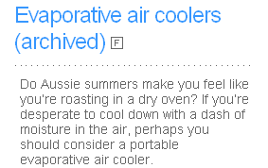

* 1. 25.0 oC to K **298 K**
  2. 4.50 x 102 K to 0C **177oC**

1. Consider the photo and diagram of a thermos flask shown below.  
     
     
     
     
   State the function of a vacuum flask and explain how it reduces heat transfer?

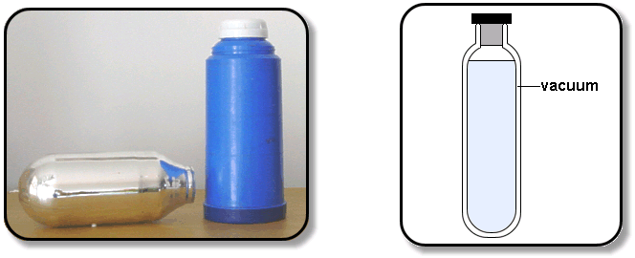

**The vacuum flask is a device for keeping liquids warm (or cold) in colder (or warmer) surroundings. It works by reducing all three modes of heat transfer. The flask consists of an insulated outer container containing the inner vacuum flask, which essentially consists of a double walled glass vessel, with an evacuated space between the walls. This reduces conduction through the vessel wall as there are no particles to transfer energy. The inner walls of the flask are coated with a thin layer of silver, acting as a mirror which reflects heat, thus reducing losses by radiation. The stopper reduces hot air losses by convection.**

1. A website states that   
     
   “**Steam is hotter than boiling water, so take the lids off cooking liquids carefully to prevent steam burns.”**Is the steam hotter than the boiling water and why are burns from steam more dangerous than burns from boiling water?

**The steam is probably at the same temperature as the boiling water, but it contains more energy. The burns from steam are much more severe since as the steam at 100oC condenses to water at 100oC, it releases latent heat of vaporisation. This latent heat release about 1000 times more energy per unit mass than does water cooling.   
So steam burns transfer the latent heat of vaporisation first, then the kinetic energy, so more damage is done.**

**[12 marks]**In an experiment to measure the temperature of a Bunsen burner flame. A 250g piece of copper is held in the flame of a Bunsen burner for several minutes. The metal is then quickly transferred to 285 ml of water contained in a 40.0 g calorimeter at 288 K  
  
  
  
  
  
  
The water into which the metal has been placed is stirred until it reaches a steady temperature of 353 K.

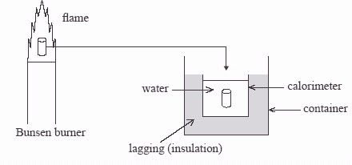

* 1. Explain why the metal is transferred as quickly as possible from the flame to the water.  
      **[2 mark]**

**So that the metal does not lose too much heat to the environment as this would lead to a lower than expected result.✓**

* 1. Explain why the water is stirred.  
      **[1 mark]**

**To ensure that the water is evenly heated, so that the final temperature is a good representation of all the water.**

* 1. Assuming negligible energy losses in the processes involved, calculate the quantity of heat absorbed by the water and the calorimeter.  
      **[3 marks]**

**Qgained = Heat gained by water + Heat gained by copper calorimeter ✓  
⇨ Qgained = mcΔt + mcΔt**

**⇨ Qgained = (0.285)(4180)(353-288) + (0.04)(380)(353-288)**

**⇨ Qgained = 77434 + 988**

**⇨ Qgained = 78.4 kJ ( 78422 J) ✓✓**

* 1. Using your answer from c) determine the temperature of the Bunsen flame.  
      **[3 marks]**

**Heat lost by copper piece = Heat gained by copper calorimeter ✓  
 mcΔt = 78422**

**⇨ (0.25)(380) Δt = 78422**

**⇨ Δt = 825✓**

**⇨ Initial temp = 825 +353**

**⇨ Initial temp = 1.18 x 103 K ✓**

* 1. If instead of water, the same mass of ethyl alcohol was used, by what factor would the temperature of this liquid change compared to the water? Show all working.   
      **[3 marks]**

**From data sheet for ethyl alcohol**

**Boiling point = 78oC ( 351K) and c = 2400Jkg-1K-1**

**Q to boil = Heat gained by ethyl alcohol + Heat gained by copper calorimeter**

**⇨ Qboil = mcΔt + mcΔt**

**⇨ Qboil = (0.285)(2400)(351-288) + (0.04)(380)(351-288)**

**⇨ Qboil = 43092 + 958**

**⇨ Qboil = 44 kJ ✓✓**

**Thus heat supplied is enough to boil the ethyl alcohol so the temp will only go to 351 K, so temp change factor is about 1 (ie unchanged) NB: about 200g of the ethyl alcohol will evaporate) ✓**